**TEAM ID: PNT2022TMID20108**

**SMART WASTE MANAGEMENT**

**TEAM MEMBERS**

**KAVYASRI.M**

**KAVEYA.PS**

**KEERTHI VARSHINI.D**

**PREETHI.B**

**INTRODUCTION**

political awareness as well as new possibilities opened by economic growth, solid waste management is starting to receive due attention. The various initiatives taken by government, NGOs, private companies, and local public drastically increased in the past few decades. Nonetheless, land filling is still the dominant solid waste management option for the United States as well as many other countries like India around the world. It is well known that waste management policies, as they exist now, are not sustainable in the long term. Thus, waste management is undergoing drastic change to offer more options that are more sustainable. We look at these options in the hope of offering the waste management industry a more economically viable and socially acceptable solution to our current waste management dilemma. This paper outlines various advances in the area of waste management. It focuses on current practices related to waste management initiatives taken by India. It also highlights some initiatives taken by the US federal government, states and industry groups. The purpose of this paper is to gain knowledge about various initiatives in both countries and locate the scope for improvement in the management of waste. Classification of waste There may be different types of waste such as Domestic waste, Factory waste, Waste from oil factory, E-waste, Construction waste, Agricultural waste, Food processing waste, Bio-medical waste, Nuclear waste, Slaughter house waste etc. We can classify waste as follows: • Solid waste- vegetable waste, kitchen waste, household waste etc. • E-waste- discarded electronic devices such as computer, TV, music systems etc. • Liquid waste- water used for different industries, tanneries, distilleries, thermal power plants • Plastic waste- plastic bags, bottles, bucket, etc. • Metal waste- unused metal sheet, metal scraps etc. • Nuclear waste- unused materials from nuclear power plants Further we can group all these types of waste into wet waste (Biodegradable) and dry waste (Non Biodegradable). Wet waste (Biodegradable) includes the following: • Kitchen waste including food waste of all kinds, cooked and uncooked, including eggshells and bones • Flower and fruit waste including juice peels and house-plant waste • Garden sweeping or yard waste consisting of green/dry leaves • Sanitary wastes • Green waste from vegetable & fruit vendors/shops • Waste from food & tea stalls/shops etc.management is starting to receive due attention. The various initiatives taken by government, NGOs, private companies, and local public drastically increased in the past few decades. Nonetheless, land filling is still the dominant solid waste management option for the United States as well as many other countries like India around the world. It is well known that waste management policies, as they exist now, are not sustainable in the long term. Thus, waste management is undergoing drastic change to offer more options that are more sustainable. We look at these options in the hope of offering the waste management industry a more economically viable and socially acceptable solution to our current waste management dilemma. This paper outlines various advances in the area of waste management. It focuses on current practices related to waste management initiatives taken by India. It also highlights some initiatives taken by the US federal government, states and industry groups. The purpose of this paper is to gain knowledge about various initiatives in both countries and locate the scope for improvement in the management of waste.

**Classification of waste**

There may be different types of waste such as Domestic waste, Factory waste, Waste from oil factory, E-waste, Construction waste, Agricultural waste, Food processing waste, Bio-medical waste, Nuclear waste, Slaughter house waste etc. We can classify waste as follows:

• Solid waste- vegetable waste, kitchen waste, household waste etc.

• E-waste- discarded electronic devices such as computer, TV, music systems etc.

• Liquid waste- water used for different industries, tanneries, distilleries, thermal power plants

• Plastic waste- plastic bags, bottles, bucket, etc.

• Metal waste- unused metal sheet, metal scraps etc. • Nuclear waste- unused materials from nuclear power plants Further we can group all these types of waste into wet waste (Biodegradable) and dry waste (Non Biodegradable).

**Wet waste (Biodegradable) includes the following:**

• Kitchen waste including food waste of all kinds, cooked and uncooked, including eggshells and bones

• Flower and fruit waste including juice peels and house-plant waste

• Garden sweeping or yard waste consisting of green/dry leaves

• Sanitary wastes

• Green waste from vegetable & fruit vendors/shops

• Waste from food & tea stalls/shops etc.

With population growth, there are tons of flats and apartments which have been built in the rapid urbanization areas like in Nairobi, Kenya. This is due to rural to urban migration in a quest to make ends meet for most inhabitants. There are several issues faced by the inhabitants of the flats. One of them is the issue of the domestic solid waste disposal, which cause pollutions. Unlike landed houses, the flats’ waste disposal bins are shared among residents which live in the same building, and thus, the bins tend to be filled very quickly. Thus, an unsystematic and inefficient disposal waste management may cause the bins to be always full with of garbage, and further littering from the residents will cause the garbage piles to be scattered outside the bins. Besides, there are also problems regarding the attitudes of each inhabitant of the flats. There are cases where some irresponsible residents, who normally live at the higher levels of the building, littered or simply threw their domestic waste directly from the floor which they live into the bins. Implementation of environmental conservation and management system is of no doubt the solution to the major problems that are currently faced when it comes to proper disposal of waste and management.

**LITERATURE REVIEW**

Solid waste management has to do with handling of solid refuse from their sources of generation through storage, collection, transportation, recovery and treatment processes to disposal. Solid waste which is one of the sources and causes of environmental pollution has been defined under Resource Conservation and Recovery Act as any solid, semi-solid liquid or contained gaseous materials discarded from industrial, commercial, mining or agricultural operations and from community activities. Solid waste also includes garbage, construction debris, commercial refuse, and sludge from water or waste treatment plants or air pollution, control facilities and other discarded materials. Thousands of lives in Kenya are lost every year to environmental-related diseases. Waste is directly linked to human development, both technological and social. The compositions of different wastes have varied over time and location, with industrial development and innovation being directly linked to waste materials. Examples of this include plastics and nuclear technology. Waste management is the collection, transport, processing (waste treatment), recycling or disposal of waste materials, usually ones produced by human activity, in an effort to reduce their effect on human health or local aesthetics or amenity. It can involve solid, liquid or gaseous substances with different methods and fields of expertise for each. Many method of waste reduction had evolve over the years and the way they are been done varies from one country to another and also with respect to the type waste generated as well as the countries productivity strength. The 3-R method of waste control is an example I. Reduce –reduce the amount of waste generated ii.reuse –making by product of particular processes reusable iii.recycle –and also recycling the abandoned part to produce new equipment’s. The aim of the 3-R method of waste management is to extract the maximum practical benefits from all generated waste products and so have to bother with minimum amount.

**Basic principles of Solid Waste Management**

1) 4Rs: Refuse, Reduce, Reuse & Recycle

• Refuse: Do not buy anything which we do not really need.

• Reduce - Reduce the amount of garbage generated. Alter our lifestyle so that minimum garbage is generated. • Reuse - Reuse everything to its maximum after properly cleaning it. Make secondary use of different articles.

• Recycle – Keep things which can be recycled to be given to rag pickers or waste pickers (Kabadiwallahs).Convert the recyclable garbage into manures or other useful products.

2) Segregation at source: Store organic or biodegradable and inorganic or non biodegradable solid waste in different bins. Recycle of all the components with minimum labor and cost.

3) Different treatments for different types of solid wastes: One must apply the techniques which are suitable to the given type of garbage. For example the technique suitable for general market waste may not be suitable for slaughter house waste.

4) Treatment at nearest possible point: The solid waste should be treated in as decentralized manner as possible. The garbage generated should be treated preferably at the site of generation i.e. every house. Based on the above principles, an ideal Solid Waste Management for a village could be as under

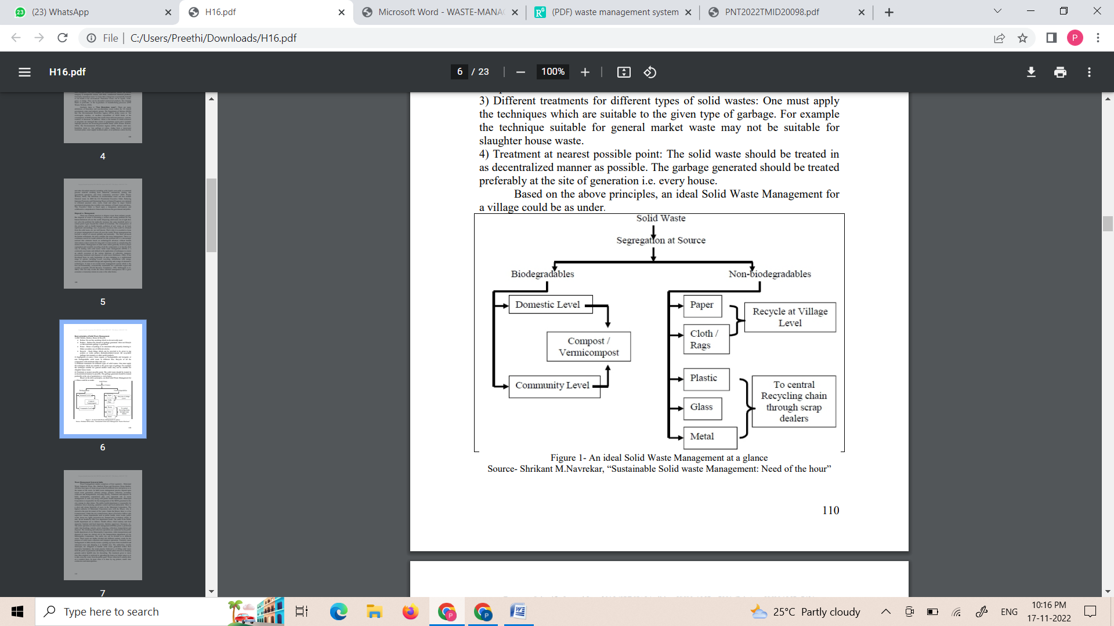

**Waste Management System in India**

Waste management market comprises of four segments - Municipal Waste, Industrial Waste, Bio- Medical Waste and Electronic Waste Market. All these four types of waste are governed by different laws and policies as is the nature of the waste. In India waste management practice depend upon actual waste generation, primary storage, primary collection, secondary collection and transportation, recycling activity, Treatment and disposal. In India, municipality corporations play very important role in waste management in each city along with public health department. Municipal Corporation is responsible for the management of the MSW generated in the city, among its other duties. The public health department is responsible for sanitation, street cleansing, epidemic control and food adulteration. There is a clear and strong hierarchy of posts in the Municipal Corporation. The highest authority of Municipal Corporation rests with the Mayor, who is elected to the post for tenure of five years. Under the Mayor, there is a City Commissioner. Under the city commissioner, there is Executive Officer who supervises various departments such as public health, water works, public works, house tax, lights, projection tax, demand and a workshop, which, in turn, all are headed by their own department heads. The staffs in the Public health department are as follows: Health officer, Chief sanitary and food inspector, Sanitary and food inspectors, Sanitary supervisor, Sweepers, etc. The entire operation of solid waste management (SWM) system is performed under four headings, namely, street cleansing, collection, transportation and disposal. The cleansing and collection operations are conducted by the public health department of city Municipality Corporation, while transportation and disposal of waste are carried out by the transportation department of city Municipality Corporation. The entire city can be divided in to different zones. These zones are further divided into different sanitary wards for the purpose of solid waste collection and transport operations. Currently waste management in India mostly means a picking up waste from residential and industrial areas and dumping it at landfill sites. The authorities, usually municipal, are obligated to handle solid waste generated within their respective boundaries; the usual practice followed is of lifting solid waste from the point of generation and hauling to distant places known as dumping grounds and/or landfill sites for discarding. The treatment given to waste once thus emptied is restricted to spreading the heap over larger space so as to take away the waste from the public gaze. Waste collection is usually done on a contract basis. In most cities it is done by rag pickers, small- time contractors and municipalities. Waste Collection in India: Primarily by the city municipality • No gradation of waste product eg bio-degradable, glasses, poly bags, paper shreds etc. • Dumps these wastes to the city outskirts Local raddiwala / kabadiwala (Rag pickers) • Collecting small iron pieces by magnets • Collecting glass bottles • Collecting paper for recycling In Delhi - MCD- Sophisticated DWM (Delhi Waste Management) vehicle There are different sweepers employed in street sweeping and primary waste collection in each city. Each sweeper is responsible for the daily cleansing of a fixed area, usually a street including all side lanes. Domestic solid waste is usually thrown on the streets directly or in plastic bags from where road sweepers collect it into heaps. These waste are then transported by hand-cart trolley to the nearby open dumps or to bins, or directly by tractor trolley to the out-skirt of the cities. The road sweepers are equipped with a broom, pan, favda (spade/showel), hand-carts, panji (small pointed hand-rake), gayti (pointed small spade to clean road-side open drains) and buckets. The waste from street cleansing is collected in wheelbarrows and thereafter; it is dumped into roadside bins or at open dumping space along with household waste. Municipal workers collect waste from collection points (open dumping spaces or bins) into various vehicles including tractors and bull carts and haul it to disposal sites. In some cases, the workers collect the MSW from the collection points using chabra (wooden baskets) and transfer it into the vehicles manually. Normally, bull carts make only one or two trips a day to the final disposal site; a tractor makes two or three trips per day whereas refuse collectors/dumper placers make four trips. Finally recycling and reuse takes place by recycling units in different cities. Recycling is related to processing of a waste item into usable forms. The concept of recycling and reuse is well embedded in India largely due to prevailing socio-economic conditions and partly due to traditional practices. In India some cities have become a hub for recycling activities as considerable amounts of recyclable materials also come from adjoining towns and villages. Recycling industry mainly process paper, plastic, glass and metals. But recycling is not a solution to all problems. It is not a solution to managing every kind of waste material. For many items recycling technologies are unavailable or unsafe. In some cases, cost of recycling is too high. Recycling forms a big part of informal sector engaged in solid waste management. Waste recycling has, in fact, both organized and unorganized sections. The lower segments working as waste and dump-pickers, itinerant waste buyers, and small traders come under the unorganized segment, while the big traders, wholesalers and manufacturers come under the organized segment of the waste-recycling sector.

**Challenges in India**

Key issues and challenges include lack of collection and segregation at source, scarcity of land, dumping of e-waste, lack of awareness, etc. Simple dumping of mixed waste is the practice followed practically everywhere and especially in the developing countries as they cannot mobilize financial resources for applying expensive technology propounded by the developed countries. In India, “The new Municipal Solid Waste Management Rules 2000”, which came into effect from January 2004, fail, even to manage waste in a cyclic process. Waste management still is a linear system of collection and disposal, creating health and environmental hazards. Urban India is likely to face a massive waste disposal problem in the coming years. Until now, the problem of waste has been seen as one of cleaning and disposing as rubbish. But a closer look at the current and future scenario reveals that waste needs to be treated holistically, recognizing its natural resource roots as well as health impacts. Waste can be wealth, which has tremendous potential not only for generating livelihoods for the urban poor but can also enrich the earth through composting and recycling rather than spreading pollution as has been the case. Increasing urban migration and a high density of population will make waste management a difficult issue to handle in the near future, if a new paradigm for approaching it is not created. A strong need felt on private sector participation in waste management but we can not ignore the risk of private sector participation. Risks of private sector involvement may include a lack of transparency, a commercial failure that would then lead to disturbance of public services, or low cooperation between stakeholders. Another important questions is that how effective are the public-private partnerships? We remember that Chennai based corporation and French conglomerate Onyx partnered for garbage collection. But we really don’t know how effective it was in practical sense. The Corporation paid heavy amount for garbage clearance. But there were complaints against the company. In any case the company was simply collecting garbage and dumping it on the dumpsites. There is no engineering miracle in collecting and dumping waste. The way forward is proper waste management policies which must be adopted and responsibilities of each are defined in proper manner and correctly watched, if the municipal authorities get the private companies (like onyx) to composting and recycling wastes rather than just dumping it. There have been a variety of policy responses to the problem of urban solid waste in India, especially over the past few years, yet sustainable solutions either of organic or inorganic waste remains untapped and unattended. For developing countries, recycling of waste is the most economically viable option available both in terms of employment generation for the urban poor with no skills and investment. All policy documents as well as legislation dealing with urban solid waste mention or acknowledge recycling as one of the ways of diverting waste, but they do so in a piece-meal manner and do not address the framework needed to enable this to happen. Critical issues such as industry responsibility, a critical paradigm to enable sustainable recycling and to catalyze waste reduction through, say better packing, have not been touched upon. Recycling of only some types of materials like plastics, paper and metals is not enough. Many types of new materials mainly used for packaging are not, or indeed cannot be, recycled in the low-end technology being employed. Besides, there are serious issues of poor occupational safety provisions of the waste pickers as well as workers. In India, new and expensive technologies are being pushed to deal with our urban waste problem, ignoring their environmental and social implications. It is particularly true in the case of thermal treatment of waste using technologies such as gasification, incineration, pyrolysis or pellatisation. Indian waste content does not provide enough fuel value (caloric value) for profitable energy production. It needs the addition of auxiliary fuel or energy. Such technologies put communities to risk and are opposed widely. For example, the United States has not been able to install a new incinerator for the past five years, while costs for burning garbage have escalated astronomically with rising environmental standards in other countries. While the more developed countries are doing away with incinerators because of high costs (due to higher standards of emission control), developing countries have become potential markets for dumping such technologies.

**ASSIGNMENT 1:**

CODE:

const int trigPin = 2;

const int echoPin = 4;

const int pirPin = 7;

int pirState = LOW;

const int buzzerPin = 8;

const int redLED = 9;

int redBright = 0;

int redFade = 5;

const int greenLED = 10;

int greenBright = 0;

int greenFade = 5;

const int button = 13;

void setup() {

pinMode(echoPin, INPUT);

pinMode(pirPin, INPUT);

pinMode(button, INPUT);

pinMode(trigPin, OUTPUT);

pinMode(redLED, OUTPUT);

pinMode(greenLED, OUTPUT);

pinMode(buzzerPin, OUTPUT);

Serial.begin(9600); // initialize serial communication at 9600 bits per second

}

void distance() {

long durationInDigit;

long distanceInInches;

digitalWrite (trigPin, LOW);

delayMicroseconds(2);

digitalWrite (trigPin, HIGH);

delayMicroseconds(10);

digitalWrite (trigPin, LOW);

durationInDigit = pulseIn(echoPin, HIGH);

distanceInInches = durationInDigit/74/2;

Serial.println(distanceInInches);

if (distanceInInches > 15 && distanceInInches < 30) {

digitalWrite(greenLED, HIGH);

digitalWrite(redLED, LOW);

}

if (distanceInInches < 10) {

digitalWrite(redLED, HIGH);

digitalWrite(greenLED, LOW);

}

if (distanceInInches > 10 && distanceInInches < 15){

digitalWrite(redLED, LOW);

digitalWrite(greenLED, LOW);

}

if (distanceInInches < 5) {

digitalWrite(redLED, HIGH);

tone(8, 250, 2000);

digitalWrite(greenLED, 0);

}

if (distanceInInches > 5 && distanceInInches < 10){

digitalWrite(redLED, HIGH);

digitalWrite(buzzerPin, 0);

digitalWrite(greenLED, 0);

}

if (distanceInInches > 30 || distanceInInches < 0){

Serial.println("Distance Incalculable");

}

delay(500);

}

void reset() {

if (digitalRead(button), HIGH);

digitalWrite(pirState, LOW);

digitalWrite(redLED, LOW);

digitalWrite(greenLED, HIGH);

digitalWrite(buzzerPin, 0);

//digitalWrite(echoPin, 0);

}

void loop() {

distance();

int pirState = digitalRead(pirPin);

if (pirState==1) {

Serial.println("Motion Detected!!!");

digitalWrite(greenLED, LOW);

digitalWrite(redLED, HIGH);

digitalWrite(buzzerPin, 1);

delay(500);

}

if (pirState==0) {

Serial.println("Detecting...");

digitalWrite(greenLED, HIGH);

digitalWrite(redLED, LOW);

digitalWrite(buzzerPin, 0);

delay(500);

}

}

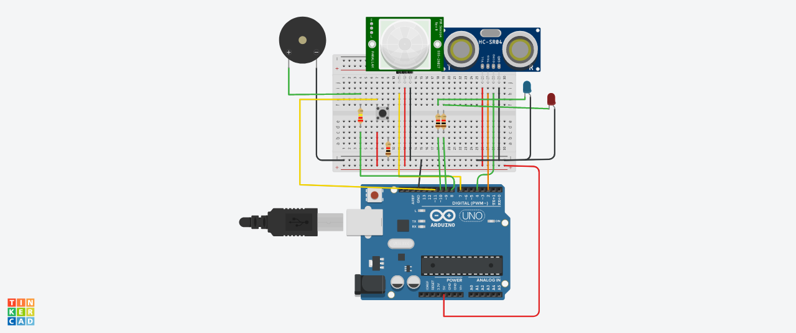

**ASSIGNMENT 2:**

CODE:

import random

import time

while(1!=0):

temperature = random.random()

humidity = random.random()

#round(temperature,2) #round(humidity,2)

print (“Temperature: ","%.5f" % temperature)

print("Humidity: ","%.5f" % humidity)

time.sleep(2)

if (temperature > 0.7):

print("high temperature")

if ( humidity >0.7):

print("high humidity")

print("")

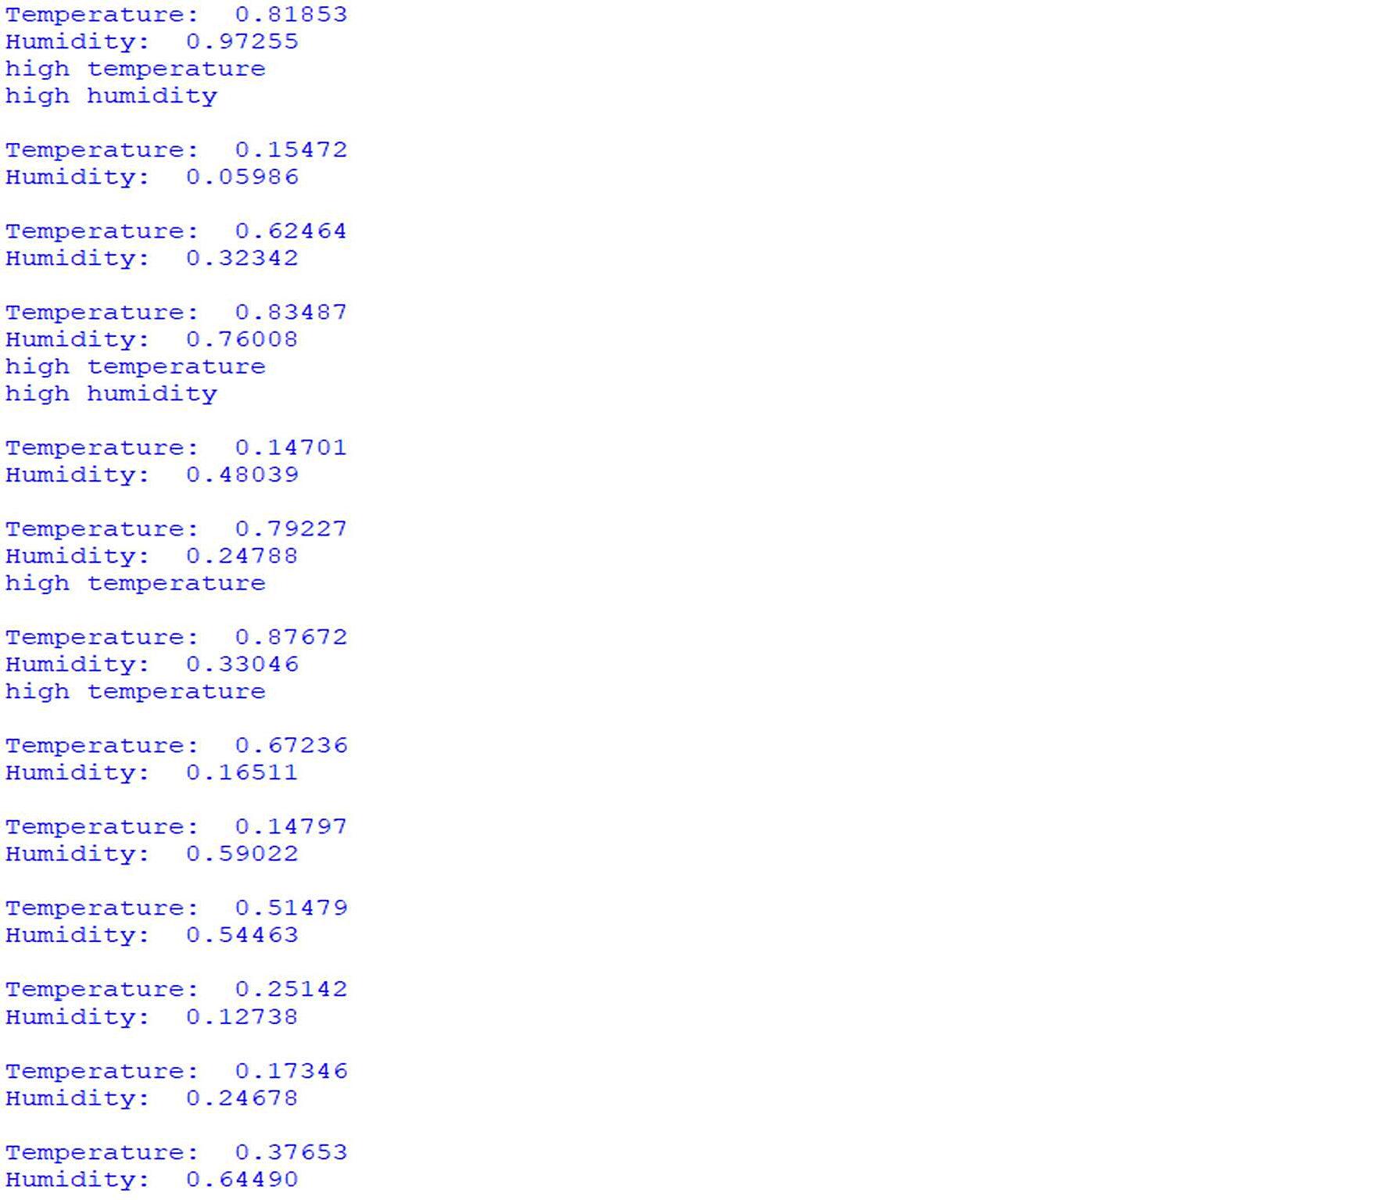

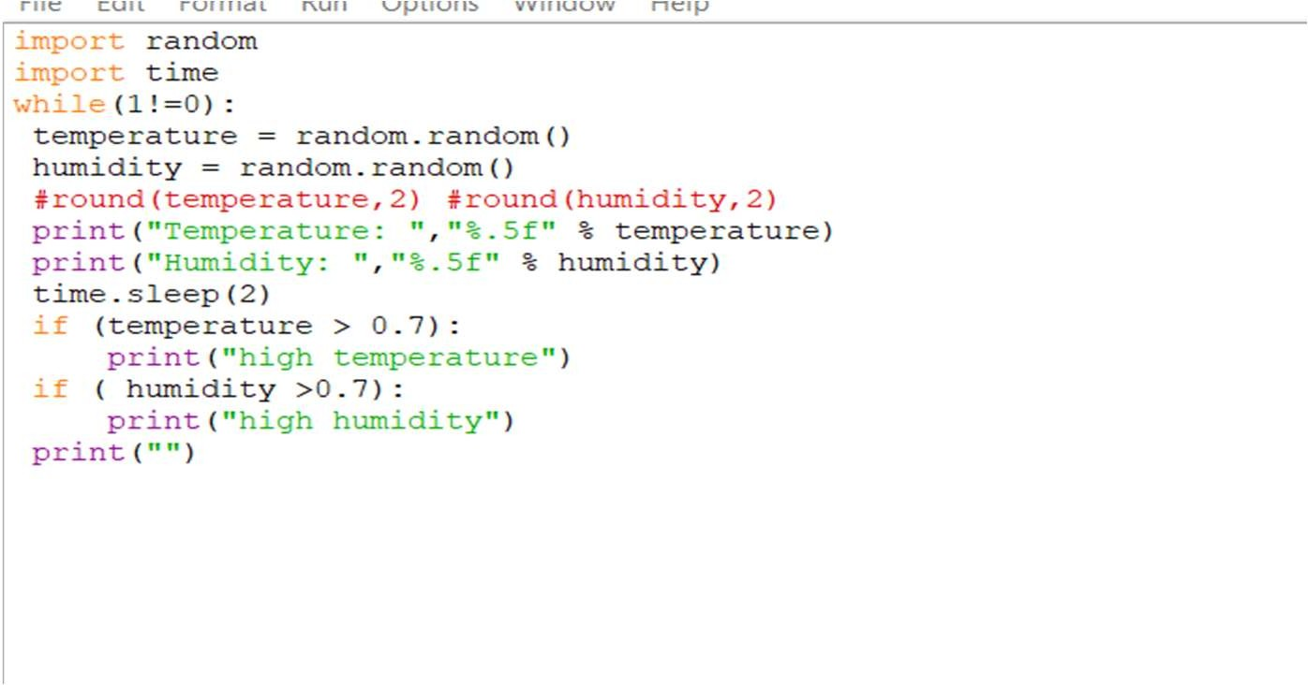

**ASSIGNMENT 3:**

CODE:

void setup() {

// put your setup code here, to run once:

Serial1.begin(9600);

pinMode(21, OUTPUT);

pinMode(20, OUTPUT);

pinMode(19, OUTPUT);

}

void loop() {

// put your main code here, to run repeatedly:

digitalWrite(21, HIGH);

delay(3000); // this speeds up the simulation

digitalWrite(21, LOW);

digitalWrite(20, HIGH);

delay(3000);

digitalWrite(20, LOW);

digitalWrite(19, HIGH);

delay(3000);

digitalWrite(19, LOW);

}

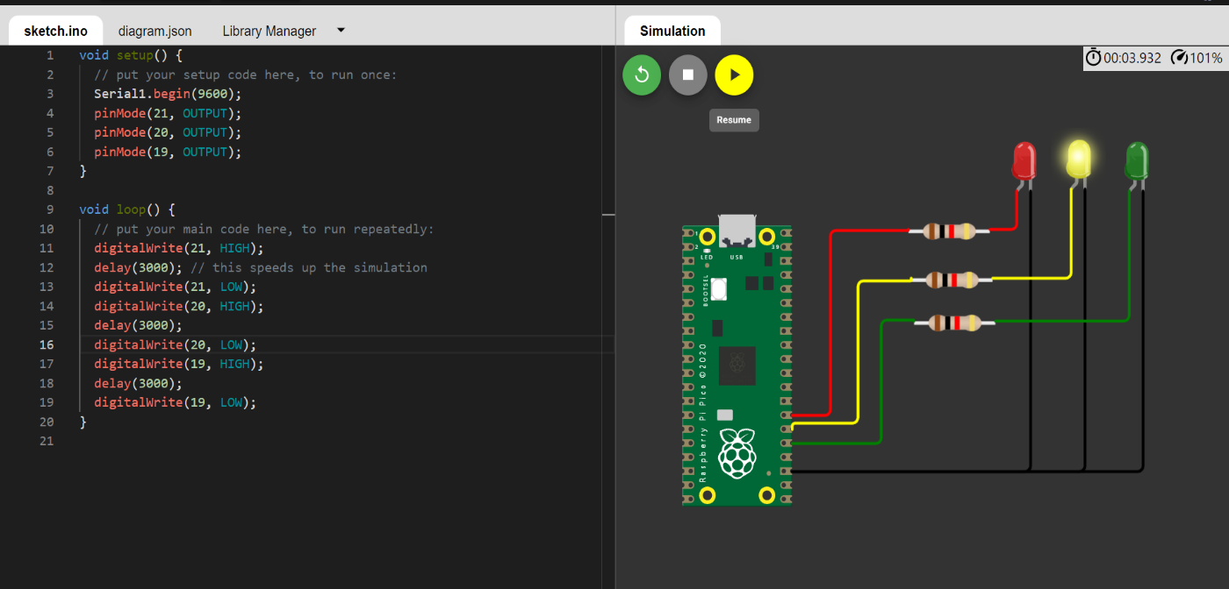

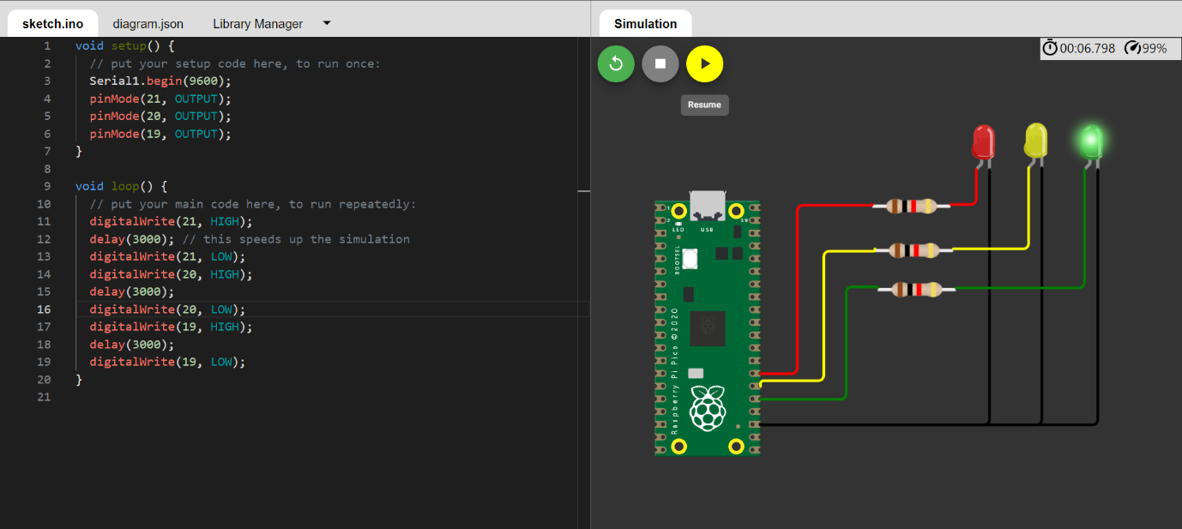

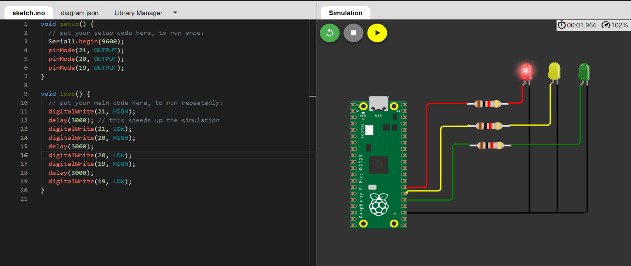

**Conclusion**

It is suffice to say that we require a more stringent integrated and strategic waste prevention framework to effectively address wastage related issues. There is an urgent need to build upon existing systems instead of attempting to replace them blindly with models from developed countries. To prevent any epidemic and to make each city a healthy city-economically and environmentally, there is an urgent need for a well-defined strategic waste management plan and a strong implementation of the same in India. To achieve financial sustainability, socio-economic and environmental goals in the field of waste management, there is a need to systematically analyze the strengths and weaknesses of the community as well as the municipal corporation, based on which an effective waste management system can be evolved with the participation of various stakeholders in India. The public apathy can be altered by awareness building campaigns and educational measures. Sensitization of the community is also essential to achieve the above objectives and we need to act and act fast as every city in India is already a hotbed of many contagious diseases, most of which are caused by ineffective waste management. All these above said suggestions are given in relation to India and will be effective only when we individually feel the responsibility of making environment clean. As general public, we can not do much in policy and regulations formulation, adoption of newer technologies related to recycling and other waste management options but we can play a very important role in this process if we can adopt only few tips. Here are a few tips to achieve this goal.

1. Keep ourself informed: It is important that we are in the know about what is happening on the environment front. Read about how untreated sewage is thrown into the rivers, attend public lectures about air pollution, & keep in touch with new policies that affect our environment. The more informed we are, the better equipped we are to fight such issues.

2. Consume less: Motto: Refuse…..Reduce….Reuse… Recycle .This means consuming fewer resources, reusing whatever we can and finally recycling what cannot be reused. This process greatly reduces the garbage.

3. Say ‘No’ to plastic bags: One of the biggest sources of pollution in Indian cities is the ubiquitous plastic bag. Refuse to accept one. Instead, carry a cloth shopping bag with us.

4. Separate our garbage: India has one of the world’s most efficient recycling mechanisms. Use the service of our raddiwalla. Newspapers, bottle cans and other such recyclables can fetch us money and in the process we can help to save the environment. Rag pickers, too, perform a vital function for the city. Kitchen garbage (biodegradable) should be separated from nonbiodegradable waste.

5. Compost our organic waste: Start a vermiculture bin. We can convince our neighbors to start a vermiculture bin also to produce manure.

6. Stop burning garbage: Ask our neighbors to desist from burning solid wastes. It may seem harmless but smoke emitted from leaves contributes to air pollution. Also, when there are plastic in the heap, it emits dangerous toxic fumes. Leaves can be converted to fertilizer through composting & plastic can be recycled.